Eugenia Skvarska is an award-winning Ukrainian stylist and artistic director. Before the start of the Russian attack against Ukraine in February 2022, Eugenia had worked as an independent stylist in Kyiv for nine years; she is not even thirty, yet her work has been featured in Harper’s Bazaar and L’Officiel Ukraine, alongside Vogue Italia and Ukraine.

After reading an interview with Elle magazine, in which she talks about her experiences as a stylist and refugee in London, I contacted her and we discussed her experience. She told me that she had dreamt of having a place to study for a master’s at Central Saint Martin’s, and that she had been previously offered a place but could not take it due to the war. ‘When I realised my previous life had disappeared- I decided to move further and try to take a place to study one more time. And thank God I did it’. To Eugenia, being London does not feel like moving to a new country, but rather like a long business trip because her heart is still in Ukraine. However, she is still trying to make the most of this situation.

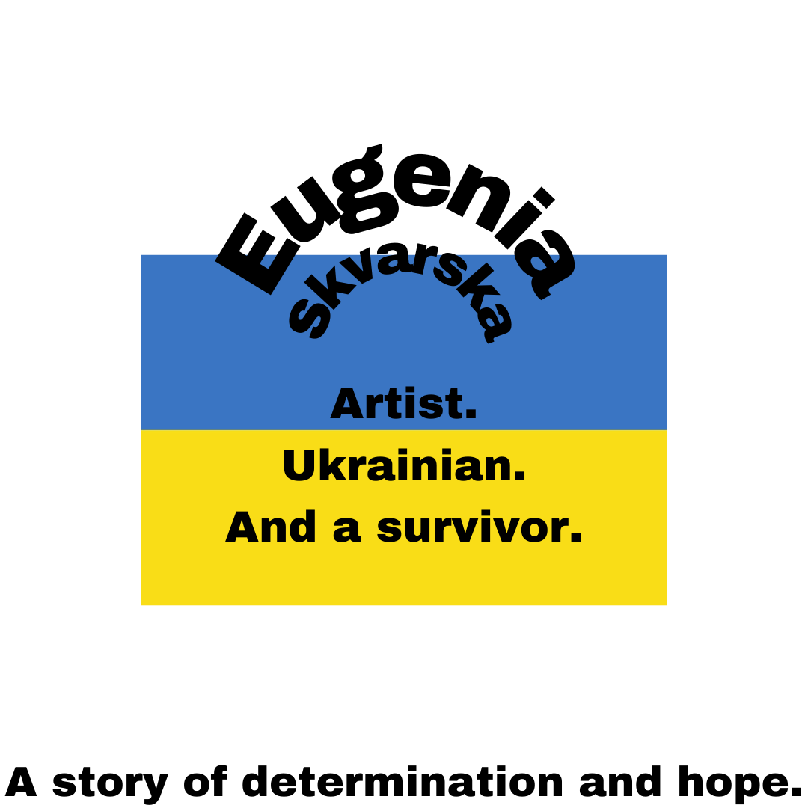
Finally, Eugenia said that she’s prouder than ever to be Ukrainian: ’Many (Ukrainians) dream about Europe and the UK, but now I know we have many things to show here. It’s our lives, our time on this planet, to make history. It feels like “now or never”, so I will play hard here. And I will be waiting for a peaceful sky in Kyiv after our win’. Eugenia’s story is one of great loss, but also of resilience, passion, and hope in a very dark time. She has been through so much, yet has managed to find the strength to invest in her future even in tragedy.

